Name: | ___________________________________________________ |  |  |  |  | Date: ___________
 | Year 8 Mathematics  Investigation 3, 2013  Topic – Linear Functions  In class component |  |  |  |  | 60  = %
Total Time: | 60 minutes
Reading Time: | 5 minutes
Working Time: | 55 minutes
Weighting: | 7% of the year.
Equipment: | Scientific Calculator, Take Home Component
Date out: |  | Week ____ Date _____________ |  | Date Due: | Week ____ Date _____________
Take home component weighting: |  | 0% of the year |  | In-class component weighting: | 7% of the year.
AIM: In this assessment, you will be investigating linear functions, rules and graphs, and apply these skills to an everyday
There are two parts to this assessment:
Item | Purpose | Marks available
Take-Home | To expand your knowledge and skill with linear functions. | 5
In-Class | To test your knowledge and skill with linear functions. | 55

A university researcher has been studying the common leafle bug. This is a pest in most gardens, and the researcher is investigating ways to control this bug. He decided to conduct his research in the Smith family’s vegetable patch.

1. | [22 marks: 4, 2, 2, 2, 2, 4, 3, 2, 1 ]
 | The number of leafle bugs increases by 10 every day. On day 1 of the study there are 15 leafle bugs found in the garden.
a) | Assist the researchers in their work by completing the following table up to day 6.
Day (D) | 1 |  | 2 |  | 3 |  | 4 |  | 5 |  | 6
Number of leafle bugs (N) | 15
Work out the differences between successive patterns
b) | Describe the pattern of differences.
c) | Working mathematically, is there a RULE to calculate the number of leafle bugs in the vegetable patch for any given day? Write your answer in words.
d) | Complete the word equation by studying the pattern and the table of values.  Total number of leafle bugs =_________ × day + ________
e) | Instead of using words, mathematicians prefer to use symbols –  N is the number of leafle bugs and D is the number of days  So instead of using words, the rule is written as:
f) | Use your rule to find how many leafle bugs there will be on day:
 | i) | 10
 | ii) | 18
 | iii) | 52
 | iv) | 215
g) | Plot the points shown in the table and join them to form a graph of this relationship. Don’t forget to label your axes.
 | 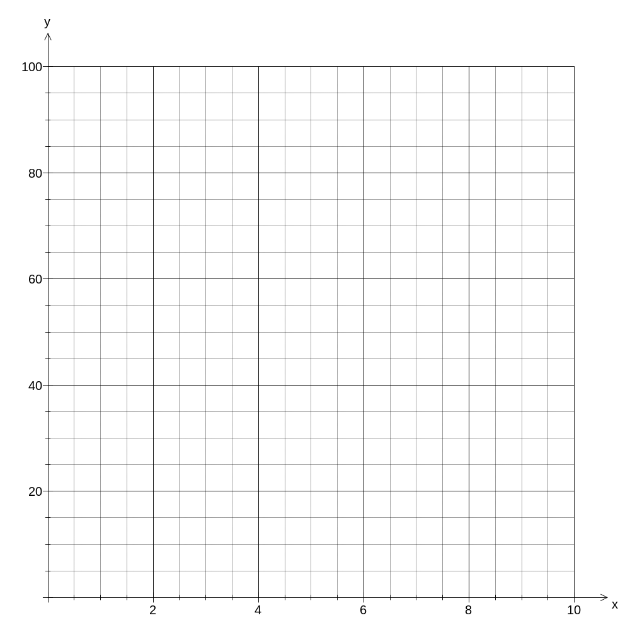
h) | Is the relationship linear? How can you tell?
i) | On a particular day, 75 leafle bugs were counted. Which day was this?

2. | [18 marks: 2, 4, 2, 5, 3, 2]
 | The researchers develop a chemical dust, code named Y, which will reduce the number of leafle bugs. This chemical will kill 5 leafle bugs every day.
a) | If chemical Y was used from day one, how would the table in Question 1(a) be different?
b) | Complete the table below showing the number of leafle bugs on a daily basis, if chemical Y was sprayed at the end of Day 1.  You need to remember that there will still be 10 more leafle bugs every day.  That means that on Day 2, 10 more leafle bugs are added, but 5 leafle bugs are killed. So, 20 leafle bugs are alive in the vegetable patch on Day 2 (15 + 10 – 5).
Day (D) | 1 |  | 2 |  | 3 |  | 4 |  | 5 |  | 6
Number of leafle bugs (N) | 15
Work out the differences between successive patterns
c) | Describe the pattern of differences.
d) | Is there a new rule to work out how many leafle bugs are in the garden each day? If so, write it below in both words and symbols.
e) | Plot the points shown in the table and join them to form a graph of this relationship. Don’t forget to label your axes.
f) | Will chemical Y ever get rid of all of the leafle bugs in the vegetable patch? Justify your answer.

3. | [15 marks: 1, 2, 5, 2, 3, 1, 1]
 | The Smith family would prefer not to use chemicals and in response the researchers decide to introduce another bug, the leafleater.
a) | If the chemicals were stopped on Day 10, how many leafle bugs were there?
b) | The leafleater bug is introduced by the researcher on Day 11. The leafleater will eat 12 leafle bugs each day. Will the number of leafle bugs increase or decrease from this day on? Justify your answer.
c) | Draw a table of results to show what will happen to the leafle bugs over time.
  Work out the differences between successive patterns
d) | What do you notice about the pattern of difference?
e) | Plot the points shown in the table and join them to form a graph of this relationship. Don’t forget to label your axes.
 | 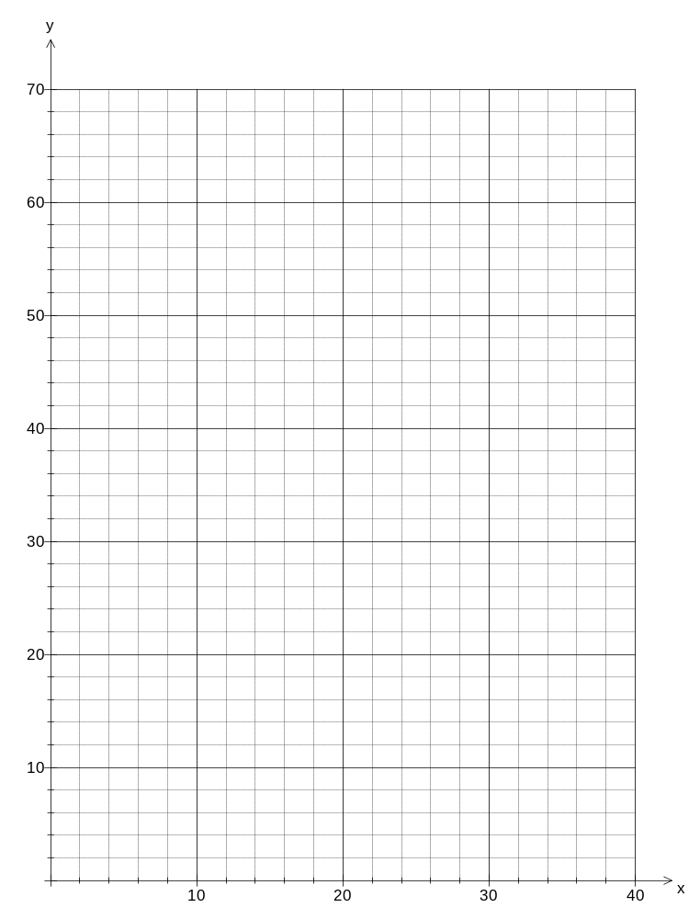
f) | What do you notice about this graph compared to the other graphs?
g) | On what day will the garden be rid of leafle bugs?

~ END OF IN CLASS COMPONENT ~

